Requirement Analysis
Data Flow Diagram & User Stories

Date | 09 September 2026
Student Name | Jetti Harika
Project Name | Automated Network Request Management in ServiceNow
Maximum Marks
Data Flow Diagram
The DFD below represents only the request flow described in the supplied project instructions: requester submission through Service Portal, catalog/variables, Flow Designer automation, Network Database record creation, approval, email notification, and status update.
Actor / Component | Data / Action | Next Component
End User / Requester | Accesses Service Portal → searches Network Requests → fills required details → submits request | Network Request Catalog Item
Network Request Catalog Item | Collects catalog variables and variable-set information | Flow Designer
Flow Designer | Get Catalog Variables → Create Record → Send Email → Ask for Approval → If/Else → Update Record | Network Database / Approval Request
Network Database | Stores request details and Approval Status | Approver / Status Tracking
Approver | Reviews approval request and approves/rejects according to configured approval rules | Flow Designer
Email Notification | Communicates request progress to configured recipients | Relevant stakeholders
Automated Network Request Management — Data Flow Diagram
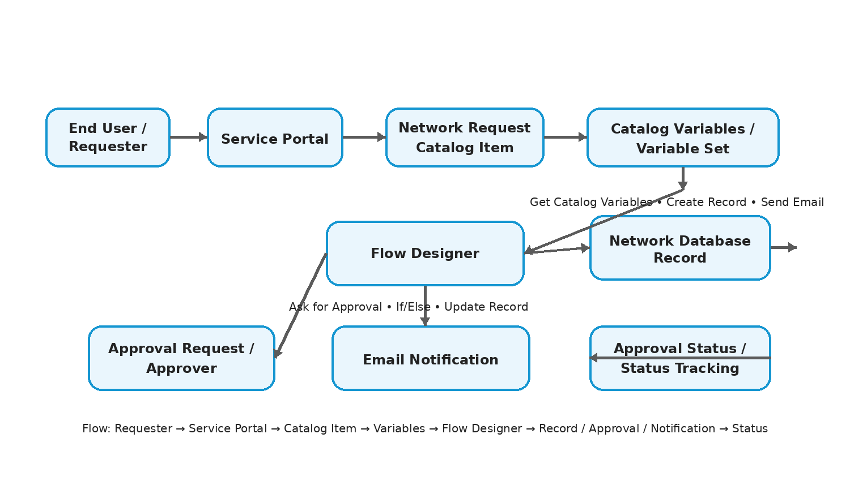
Figure 1: Request data flow for Automated Network Request Management.
User Stories
User Type | Functional Requirement (Epic) | User Story Number | User Story / Task | Acceptance Criteria | Priority | Release
End User (Requester) | Network Request Submission | USN-1 | As an end user, I can access Network Requests through the Service Portal and submit a network service request. | Network Request item is accessible and a request can be submitted with required details. | High | Release-1
End User (Requester) | Request Details | USN-2 | As an end user, I can provide the required network request details through the catalog form. | Required variables are available and mandatory information can be entered. | High | Release-1
End User (Requester) | Dynamic Form | USN-3 | As an end user, I can see the Existing ID field when Type of Connection is Existing. | Existing ID becomes visible when the configured condition is met. | Medium | Release-1
End User (Requester) | Request Tracking | USN-4 | As an end user, I can view the request approval status. | Approval Status is maintained on the Network Database record. | Medium | Release-1
IT Admin | Automation | USN-5 | As an IT admin, I can automate the network request lifecycle using Flow Designer. | Configured flow executes the specified actions after catalog submission. | High | Release-1
IT Admin | Data Record | USN-6 | As an IT admin, I can create a Network Database record from the submitted catalog variables. | Create Record populates the specified Network Database fields. | High | Release-1
Approver | Approval | USN-7 | As an approver, I can review and approve or reject a network request. | Approval request is created and the configured approval outcome is captured. | High | Release-1
Network Fulfilment Team | Request Processing | USN-8 | As a network fulfilment team member, I can use the centralized Network Database record to execute and track network changes. | The record contains the specified request and approval information. | High | Release-1
Relevant Stakeholders | Notifications | USN-9 | As a relevant stakeholder, I can receive an email notification about request progress. | Send Email action sends the configured notification. | Medium | Release-1
IT Admin | Security | USN-10 | As an IT admin, I can use configured ACLs to restrict read/write access to the custom table. | Default ACLs are applied to the custom table as specified. | Medium | Release-1

